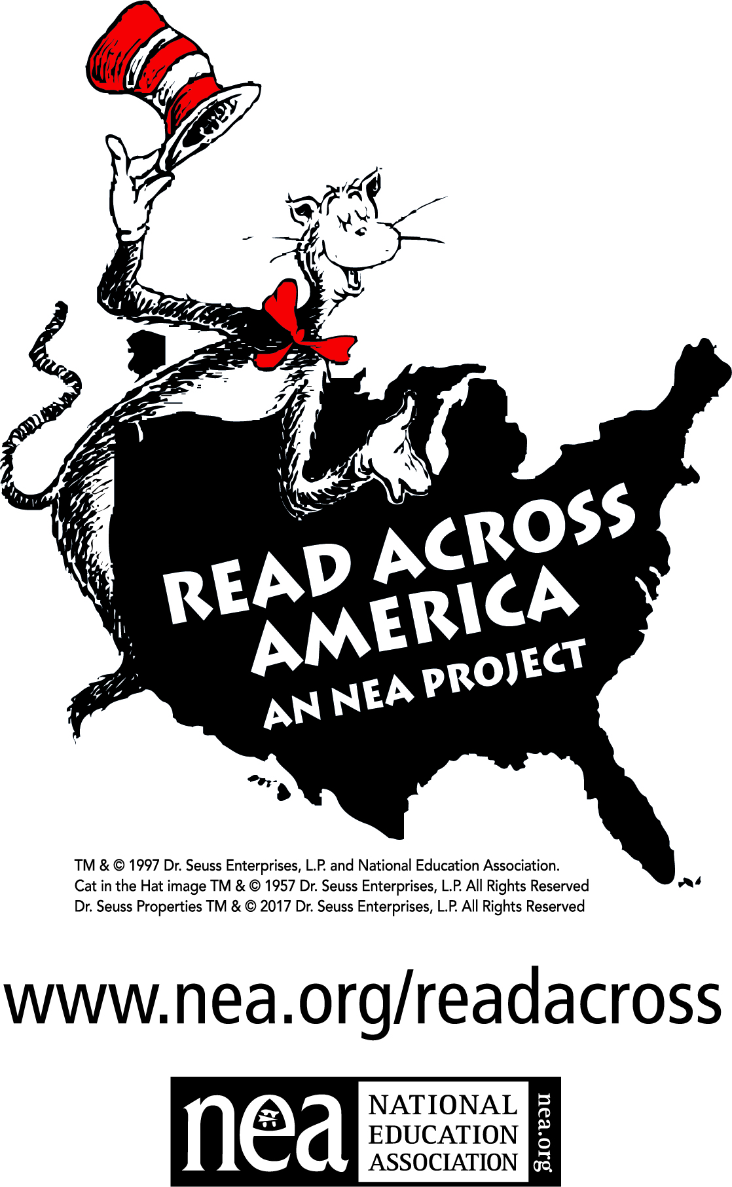

Sponsored by the

TEACHERS ASSOCIATION OF BALTIMORE COUNTY

AFFILIATED WITH NEA/MSEA

Saturday, March 3, 2018

10:30 a.m. to 1:00 p.m.

Towson Town Center

Grand Court, Level 1

**JOIN THE FUN!**

* Guest Readers
* Activities for Children
* A Visit from

The Cat in the Hat

* Informational Displays